

Programme Name: ________**BCS HONS**_______________________________________

Course Code: __**CSC 2201**_______

Course Name: ________**Human Computer Interaction**______________________________

**Individual Project** No. _**1**___

Date of Submission: ______**/2020**_____________

**Submitted By: Submitted To:**

Student Name**: Dipesh Tha Shrestha** Faculty Name**: AKASH DEO**

IUKL ID: **041902900028** Department**: LMS**

Semester**: Third Semester**

Intake**: September 2019**

**Anime streaming site**

**Table of contents**

1. **Context of the topic**
2. **Inspecting/** **interface between user and product.**
3. **System/Task/User Characteristics**
4. **Problem Identification**
5. **Conclusive Approach.**

**Context of the topic**

Anime is one of those entertainment mediums that people seem to get a bit apprehensive about. Anime and cartoons give the intuition of movement. Watching animes and cartoons is a passion to many people both adults and children. Worldwide most people like watching animes and cartoons to keep them busy. There are many TV stations that have animes and cartoons. The animes and cartoons range from daily episodes to series. We didn’t have a problem watching Pokemon or Doremon before school in our younger years, and in fact, you probably look back on those memories with undeniable fondness. However, the older people get, the more likely they are to shunt anime off to the side and label it as a no-go.  Animes may be hand was drawn or computer animated productions. One can download them or watch online even with the use of their phones.

To adults, watching animes and cartoons is good to relax especially after a tiresome day. Many adults watch cartoons and animes to relax and feel relieved. When people are stressed, the best way to get rid of stress is by watching animes and cartoons. They create great laughter that make people forget most difficulties they have been going through. The thing I love about anime is **it’s not just pure entertainment, it’s also**inspirational. It makes you want to do something in your life. It gives you reasons to become more than you are, and make something of yourself.

I think just about everyone has had a terrible day at some point. One of those days when you don’t feel like dealing with anyone or anything.Anime is perfect for those kinds of days. Regardless of what you feel like watching, there’s bound to be an anime to fit the way you feel. Anime has many genres, some of which are more lighthearted, sci-fi, or serious than others. You can easily find something to inspire you with hope, or something to cater to your bad mood.

Anime can convey strong messages through its characters, its setting and the general vibe that could come from a single episode. Its why it’s loved worldwide, and the industry, increases in popularity as more and more people start to watch Anime and cartoons.

The project is solely dedicated towards inspecting 4 Anime streaming website and their user interface problem.

**Inspecting/ interface between user and product.**

We will be looking towards 3 Anime Steaming Site. These are the most popular one and most loved by users or viewers.

1. **KissAnime**
2. **GoGoAnime**
3. **Chia-Anime**

**KissAnime**

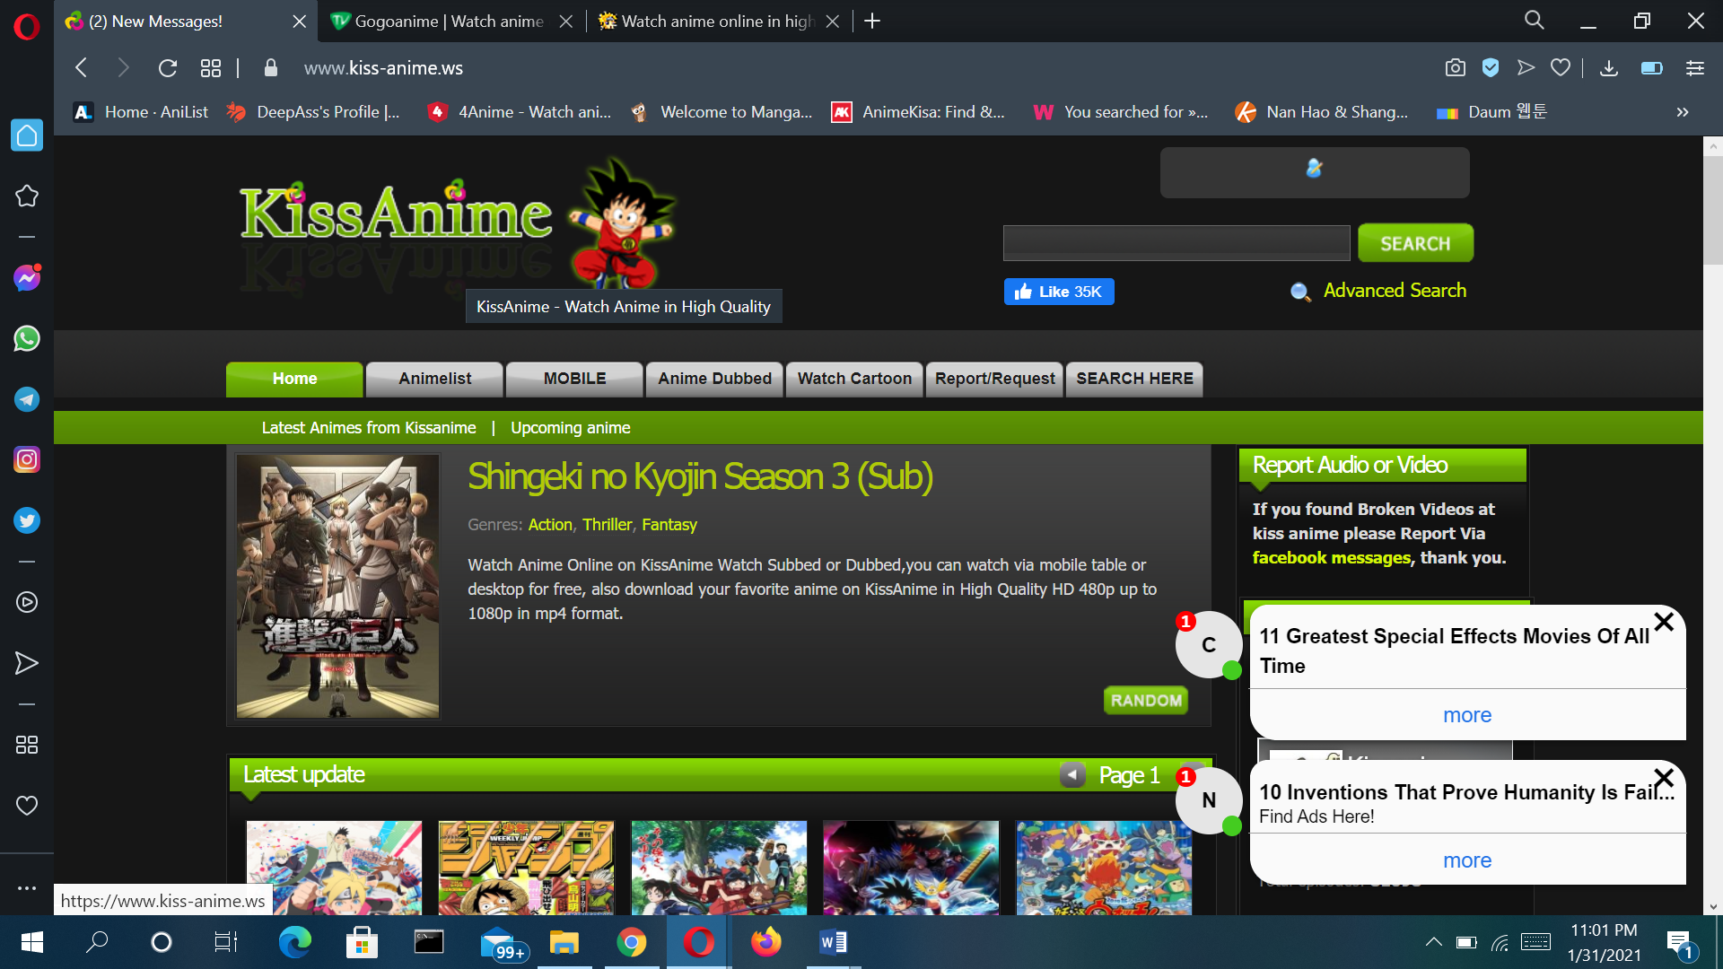

**KissAnime** is one of the largest anime streaming networks, and it boasts a rich community that helps you socialize with other anime fans and make different discussions..

When it comes to title hosting, there’s no anime that KissAnime won’t offer. It sports an extensive anime list which continually gets updated, mobile navigation to help you watch on mobile device, chat rooms so that you and other people can discuss on-air episodes, as well manga reading features. Moreover, visual novels are also popular on KissAnime.

The website is free to use and is supported through ads. While this is good because it doesn’t require registration and credit card input, those ads can be of inappropriate content, misleading or disturbing to children, who are major anime fans. Visitors can whatsoever keep up with the latest anime classified in different genres, able to sort among popular and latest titles. Video quality is respectful; each anime has a summary; there are reliable English subs and much more.

Another minor drawback is that visitors will need to insert captcha before they can start watching.

**Pros:-**

* The website provides dubbed animations which eradicate the use of subtitles that can often block the video content.
* You can save all of your favorite animes at the top of the homepage so that it’s easier to access series you are watching without having to keep on searching for the same.
* The thumbnails have great animations which act as previews to what’s in the anime series episode or movie.
* The categorization of videos is super convenient for the user.
* The episodes and movies on the Kissanime website are of high quality and add to a fantastic user experience watching the same.

**Cons:-**

* Since it is a free website, it is full of irritating advertisements that pop up multiple times. There are several complaints of even inappropriate adult advertisements.
* You cannot change the video resolution on the website.
* The website may ban you if you use an Adblocker or VPN.

**Usability issues:-**

* A lot of inappropriate ads.
* Requires signing captcha before watching specific anime series.
* Unattractive design
* Not compatible with all devices.
* Unmanaged genres and library
* Tiny text links

**GoGoAnime**

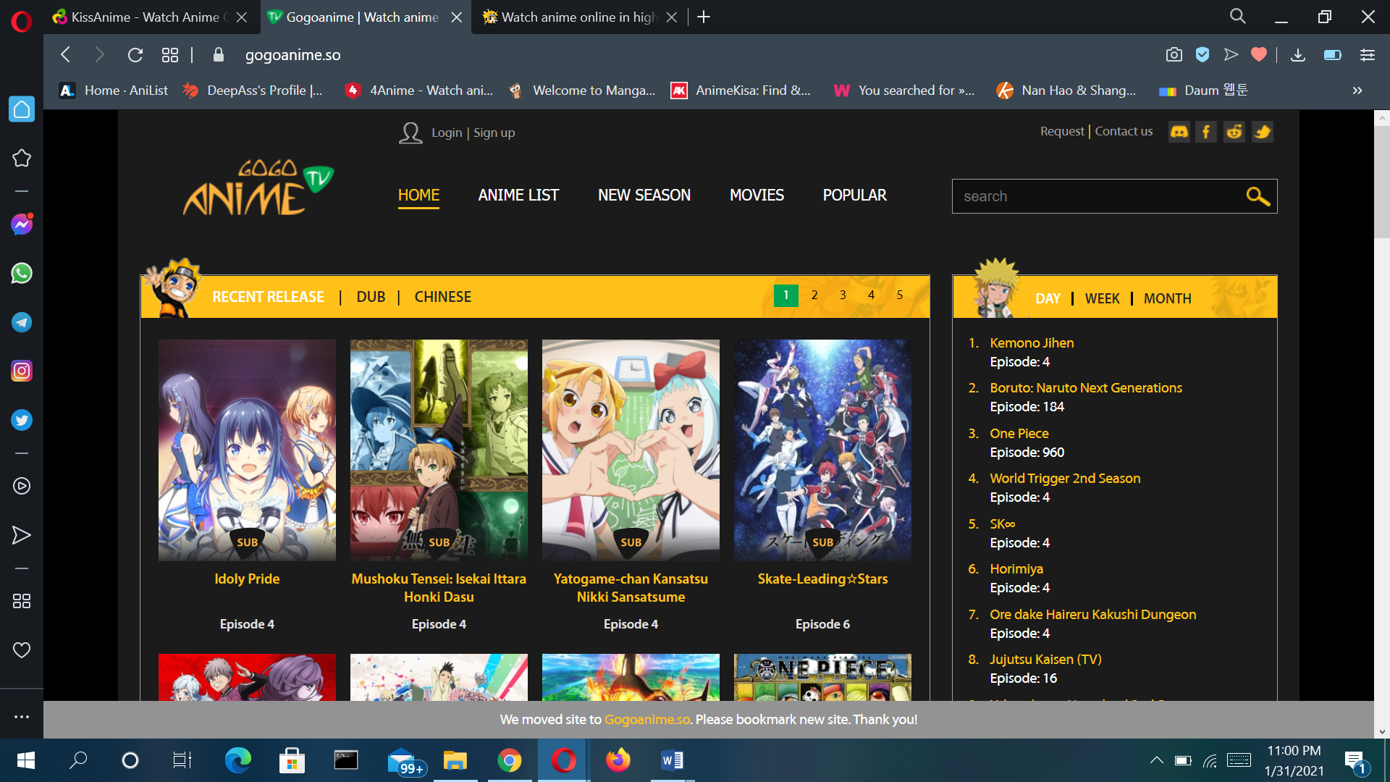

**GoGoAnime** is yet another great website where to watch anime for free. On this website, you can see the latest updates of the shows you’re watching, including the latest plots of those shows.

This anime streaming site is fantastic because it provides you with exceptionally high-quality streaming services, and you will love this site.

The best part about GoGoAnime is that it is very dedicated to the streaming of Japanese shows and movies, which is understandable for English-speaking audiences, i.e., subbed anime. However, this does not mean that GoGoAnime does not also offer English-dubbed Japanese anime.

The website also has a very user-friendly interface, and you won’t have much trouble trying to figure out your way around it. The upper half of the home page is dedicated to displaying thumbnails of anime shows and movies, while the bottom half is for manga comics.

**Pros:-**

* The simple user interface which is very friendly and easy to navigate around
* GoGoAnime website has a wide range of comics and anime series as well as movies, which will keep you entertained as and when you want to be
* Other than having a wide range of manga and anime, GoGoAnime also has all the latest episodes
* Adding to its other features, the near distance range for Asian as well as other servers is brilliant

**Cons:-**

* Understandably, free content streaming websites need an income to run effectively, which is why there are ads on them. However, GoGoAnime is one such example of a site which has too many ads, to the point that it’s difficult to differentiate certain ads from the actual content
* Aside from acknowledging the fact that the website for anime streaming GoGoAnime, has too many ads, we must also recognize that many of these are inappropriate adult ads. This is highly unsafe for children who like to stream Japanese cartoons.
* You may accidentally download a virus off of this website due to its pop-ups.

**Usability issues:-**

* Slow server
* Small fond size
* Tiny Text link

**Chia-Anime**

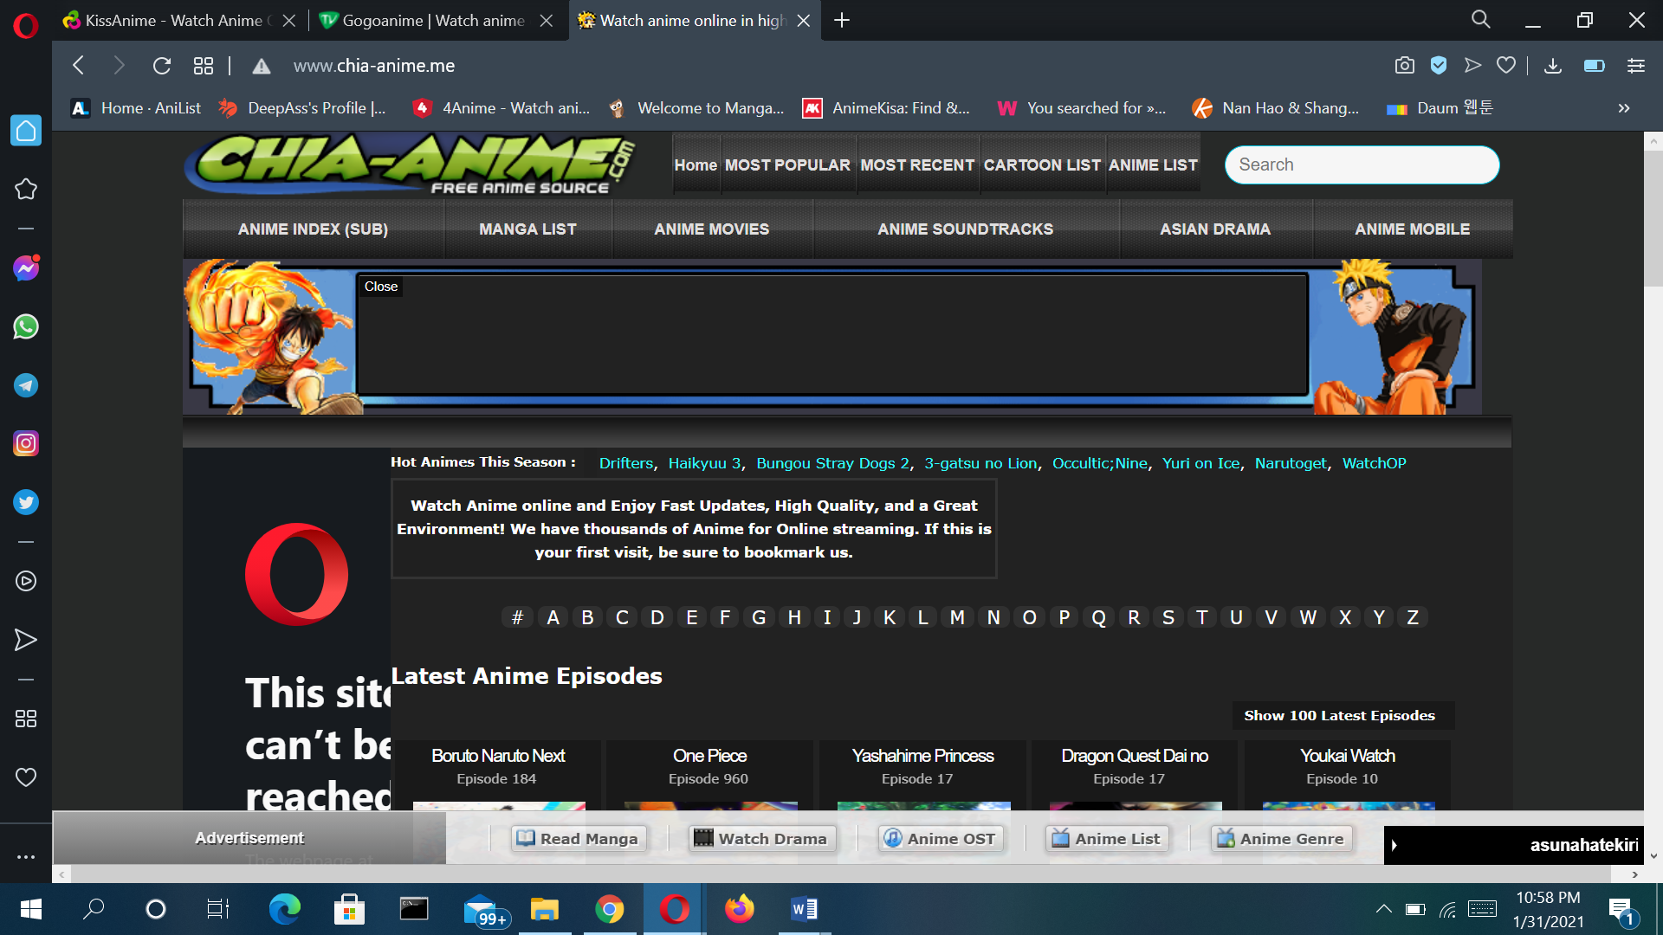

[**Chia-Anime**](https://www.chia-anime.me/series-letters/?tags=a) is yet another one of the best anime sites to stream anime and watches it as per your liking. It is one of the best websites because even though there are ads, you can block them easily using an Ad Blocker plugin on your browser or device.

This particular website is one of the newer ones that have entered the market of anime streaming sites. Having this particular argument in favor of it, Chia-Anime is one of the websites with more advanced features than others.

It has millions of viewers per day despite it not being all that old in comparison with other similar sites.

One more feature of Chia-Anime that stems from it being of relatively recent origin, the website is unique in its way. This is in the sense that it is a little confusing to figure out at first; however, it is relatively easy to get the hang of after constant use.

Of course, for anime lovers, constant use of such websites is a given, so the interface is not problematic at all.

**Pros:-**

* Chia-Anime is a fairly new website, which is why it has some great new features inculcated in it right from its conception rather than via updates later on
* A lot of anime sites have the power to block you or ban you from signing on if you are found to be using an Ad blocker plugin for your browser or device. Chia-Anime allows Ad blockers, which is one of the primary reasons why it’s a great website
* While the user interface is fairly confusing at first, do understand that once you have figured your way around it, it is one of the smoothest and most unique interfaces that you will have used
* There are multiple player channels for videos on the website, and thus if one of the players does not work for you, you can try another one for the same episode without worrying about it

**Cons:-**

* The biggest problem that some users may find with Chia-Anime is that they only have subbed videos. Thus, for those who prefer dubbed over subbed anime, this is not the site for you. If you prefer subbed, then Chia-Anime is perfect for you
* The website is slightly confusing to figure out.
* If you don’t have an Ad blocker installed, there are ads with every click you make on the website, which can be super inconvenient

**Usability issues**

* Ads irritate.
* Unclear navigation
* Poor image quality
* Auto playing Music
* Overloaded

**System/Task/User Characteristics**

**System Charactertics**

Considering the incredible number of people that have turned anime into a lifestyle, it's not surprising that there are hundreds of websites where fans can watch anime series online for free or with a subscription. Although the interest in an animation form that brings something different from classic Western cartoon series is encouraging, it should be mentioned that not all anime websites are what they claim to be. If you are looking for a platform where you can watch all your favorite shows and discover new ones and you don't know where to start your search, then here are a few guidelines to help you sort the options. Needless to say, the quality of the videos is a must and you shouldn't settle for anything that has less than HD. There are many websites to choose from and you shouldn't make compromises, because there is always something better out there.

The first thing on the list is genre diversity. The perfect website should have it all - and not just the typical movie genres that Western movies offer (comedy, action, romance, horror, science fiction), but also several other genres that are specific to Japanese anime. This includes subcategories such as Shoujo, slice of life, dystopia, Shounen, Mecha and many others. Genre separation is incredibly important in the anime world and it's even a topic of heated debate among fans. Most people only prefer several genres and hate all the others with a passion, so the website where you watch anime series online should allow you to sort all of the anime into categories, otherwise you'll have a hard time finding something new to watch. A rating system would also be nice, because it will save you the trouble of finding low quality videos, videos that don't load, videos where the subtitle is missing or just bad anime in general. In addition, a comment section or chat is always welcome, because you can meet people from all over the world who share your hobby.

Here are some system charactertics of anime streaming site

* light and dark themes.
* low bandwidth.
* Easy access.
* Wide range of collection.
* Compatibility with many devices.
* Clean and catchy interface
* Comprehensive navigation
* Quick filter
* Language change

**User Characteristics**

User characteristics and product properties are a useful source of information that help designers to foster such a understanding of target users and the product in development. When designing for a specific user group, the ‘user characteristics’ helps you to better understand the target group and predict usability problems in practice. When designing for ‘all’, the ‘product properties’ helps you anticipate usability problems of your next generation products at the start of the product development process. These user characteristics encompass cognitive aspect, personality, demographics, and use behavior.

People who are remotely open minded (to understand at some level the fact that it might be animated because it would be too expensive and not so appealing to do the same thing in live action and not because it's for children), creative, optimistic, upset, emo, seeking validation, lovelorn, those who grew up with it, those who like to learn about cultures and languages, art appreciators like to stream anime in this site.

There is age restriction in some streaming website but most of the streaming website does not contain any age restriction. Anyone can visit such website which doesn’t contain any age restriction. Most of the people who visit this website is for entertainment.

To adults, watching animes and cartoons is good to relax especially after a tiresome day. Many adults watch cartoons and animes to relax and feel relieved. When people are stressed, the best way to get rid of stress is by watching animes and cartoons. They create great laughter that make people forget most difficulties they have been going through. The thing I love about anime is **it’s not just pure entertainment, it’s also**inspirational. It makes you want to do something in your life. It gives you reasons to become more than you are, and make something of yourself.

**Problem Identification**

There are some problem in this website. Some of them are:

* This streaming site can be addictive, people once start watching and cannot get enough of it which is quite dangerous.
* Some site doesn’t store any files on its server. A non-affiliated third party provides content.
* These Steaming services are not available in all countries.
* Some site might not support IOS devices for streaming anime content that makes it difficult for most users with no android devices.
* Some of these site is considered illegal and can have consequences.
* You may accidentally download a virus off of this website due to its pop-ups.
* Aside from acknowledging the fact that the website for anime streaming in this website, has too many ads, we must also recognize that many of these are inappropriate adult ads. This is highly unsafe for children who like to stream Japanese cartoons.

Conclusion:

All the anime streaming sites that are mentioned above are widely used all over the world. They are jumbo packages for the smooth streaming of anime movies or episodes. All the websites combine to help you with all genres, categories, and kinds of Anime, including martial arts, tv-series, graphic novels, and comics.